**DAILY ONLINE ACTIVITIES SUMMARY**

|  |  |  |  |  |  |  |  |
| --- | --- | --- | --- | --- | --- | --- | --- |
| **Date:** | **29/06/2020** | | | | **Name:** | **Sinchana K N** | |
| **Sem & Sec** | **IV sem & B section** | | | | **USN:** | **4AL18CS083** | |
| **Online Test Summary** | | | | | | | |
| **Subject** | | **-** | | | | | |
| **Max. Marks** | | **30** | | **Score** | | **-** | |
| **Certification Course Summary** | | | | | | | |
| **Course** | **Excel for beginners** | | | | | | |
| **Certificate Provider** | | | **Greatlearning academy** | **Duration** | | | **4.5hours** |
| **Coding Challenges** | | | | | | | |
| **Problem Statement1:** Given a list of numbers, write a Python program to count Even and Odd numbers in a List. | | | | | | | |
| **Status: Executed** | | | | | | | |
| **Uploaded the report in Github** | | | | **YES** | | | |
| **If yes Repository name** | | | | **https://github.com/acchu1234sinchana/Lockdown_coding1** | | | |
| **Uploaded the report in slack** | | | | **YES** | | | |

Online Test Summary: No internals conducted today.

Online Certification Course Summary: In today’s session I have learnt about Data Aggregation and Data Visualization.



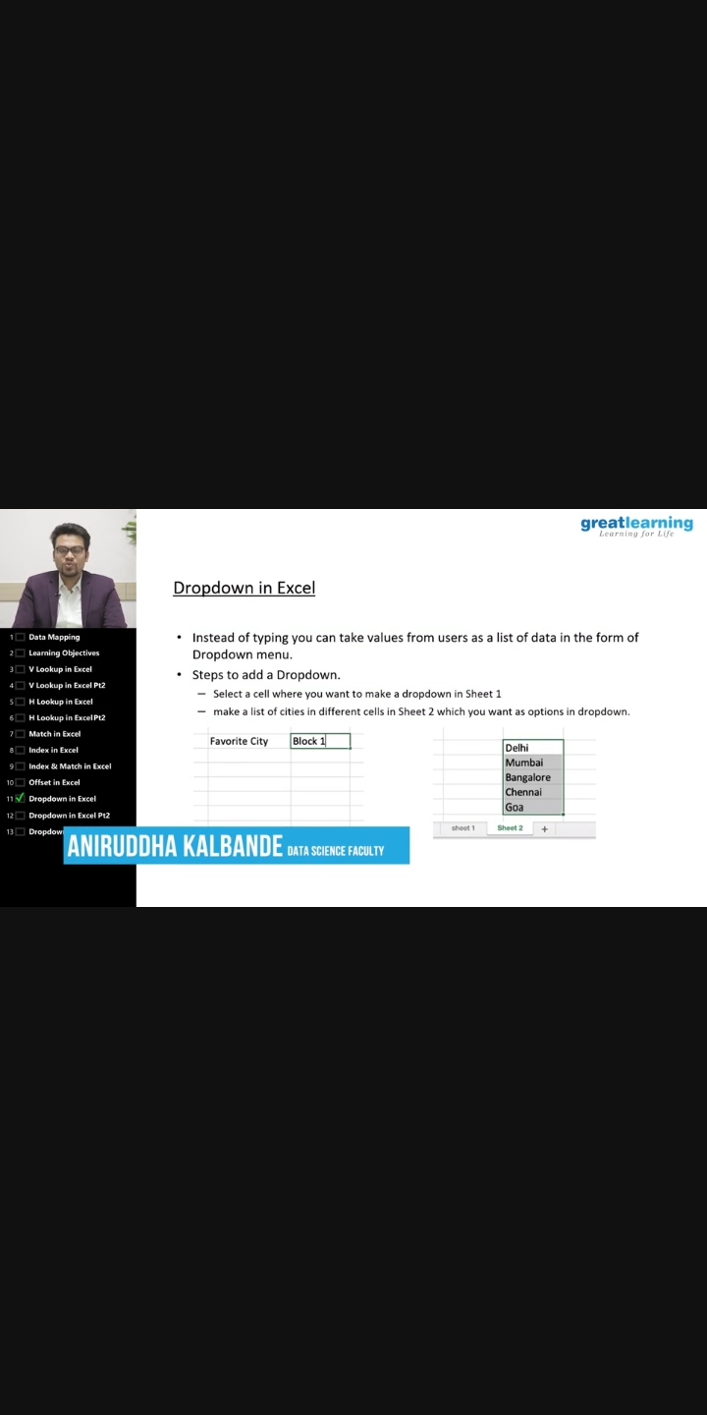

This is the snapshot of today’s session.

Online Coding Summary: **Today I had received one program from prof. Vasudev CSE Dept.The program is mentioned above in the coding challenges(pg.01). I have also uploaded it to my Github repository.**

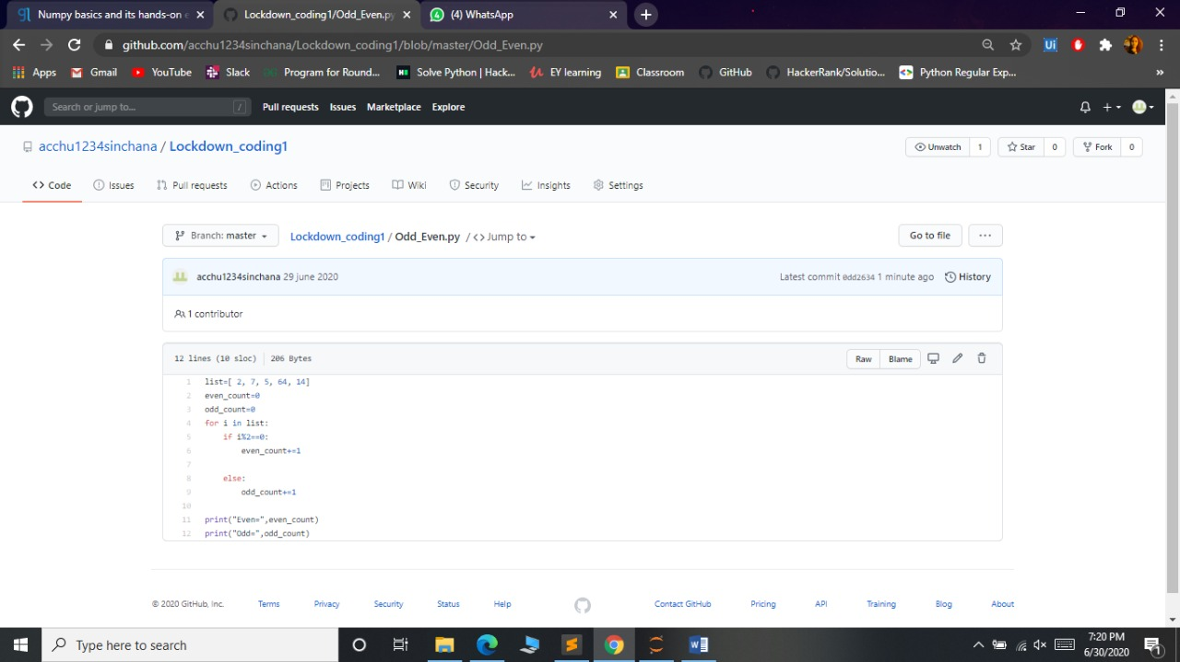

Online Training: Today I had attended the online training organized by CSE Department AIET. The training was on Cyber Security and its Applications done by Dr. Manjunath Kotari HOD CSE Dept. After the session the quiz was conducted.